

|  |
| --- |
| **Deliverable 5**  **TEAM RED**  **Theodore Tsimiklis (2065694) Jiahui Xia (2044092)**  **George Athanasatos (1951431) Andrei Marinescu (1972210) Client: Samer Assi**  **2022/03/30** |

**Vanier College**

**Computer Science Department**



**i**

**Table of Contents**

EXECUTIVE OVERVIEW 1

SUMMARY OF THE CLIENT 1

NARRATIVE DESCRIPTION OF THE PROJECT 2

BUSINESS PROBLEM 4

Our way to resolve these problems: 4

10 USABILITY GUIDELINES 5

COPIES OF THE PROTOTYPE INTERFACES 6

CLIENT’S COMMENTS 7

APPENDIX 2 –REVISED STORY MAP 18

CONFIRMATION OF EACH TEAM MEMBER 20

REFERENCES 21

# EXECUTIVE OVERVIEW

In this deliverable, we develop a UI mockup to visualize our goals for this project as well as to show our client what we have envisioned and if he would have some comments on what to add or remove. To do so, we used Adobe XD to map out the website pages, as well as the functionalities that we have specified in the mockup. This also demonstrates the flow of our website and how it will operate.

After the completion of the mockup, we contacted our client to see how pleased or displeased he would be towards it. He gave us some good and detailed comments as we will show soon and have/will change it to his liking. Then we will discuss how the project has changed throughout the previous deliverables.

# SUMMARY OF THE CLIENT

Since our last deliverable not much has changed about our client Sam. As mentioned, he is still well equipped with computer knowledge and progressing smoothly with his business. One thing our client started to do is go door to door to find clients for his business. Right now, he has signed 3 contracts and is looking to find more. Our website web application will facilitate

# NARRATIVE DESCRIPTION OF THE PROJECT

There is no change about system actors and actions in our system.

We have identified three primary roles relevant to the system. First, there is the user as a generic role; it represents anybody using the system, including anybody attempting to use it without prior authentication as well as anybody trying to perform a non-privilege-based privilege such as login, sign up or logging out. Then there are the administrators who can be thought of as the owners of the website; they have control of what is shown on the website, they can view critical information such as client profile (client information), bookings, services... Finally, the client is a role with limits who possess accounts on the website and who can set up bookings. The system will purposely maintain a separation between roles and permissions so that there are no roles and potentially hinder the website’s data.

The actions an unprivileged user can take will be minimal. A viewer can view the website through clicking the links in navigation bar and choose the language which will display on the website. However, a viewer cannot make a booking or have a profile. A viewer be able to try sign up or login, it’s depended on if he/she has an account.

When a viewer signup, the viewer needs to input a unique username. Otherwise, the viewer cannot complete sign up. At the same time, the viewer needs to input the password twice and, and the password need to be the same.

When a viewer provides the matching identifier and password, the viewer become a client. A client is still an unprivileged user but he/she can have more actions than a viewer. A client can view all the information about the website. A client is able to create a profile page and edit his/her profile. A client is able to make a booking but need to choose a service, enter contact information and pick up the time and date. A client also can add addition information(note) during making a booking. Finally, a client needs to confirm his/her booking to finish booking. A viewer also can ask question in contact us page. A client needs to input the contact information and input his/her question. Finally, a client needs to confirm all the information is correct, then the question will be sent to database and admin can see the question.

Once authenticated, if a user turns out to belong to the administrator role, he/she officially becomes an administrator. An administrator has create, update and delete permissions for services. This is means that he/she can add, remove or change a service. An administrator also has read permission for reading all the client’s profile(information). One key ability for the administrator is to quickly see all the bookings or specific booking; to that end, the system will provide a number of facilities. The administrator will be able to sort bookings by alphabetical client’s name as well as date. The administrator also can edit the store location, store contact phone and social media buttons.

Another key ability for the administrator is to quickly see all questions from clients. The administrator will be able to sort questions by alphabetical client’s name as well as date. The administrator also can see the status of questions. He/ she can see which of client’s questions have been answered and which have not been answered.

# BUSINESS PROBLEM

The painting business that we are working for has a couple of problems regarding the promotional aspect, customer experience, as well as the lack of demand for his services. There are multiple ways to resolve these issues and the application that we are meant to design for our client is designed to resolve at least the named ones.

## Our way to resolve these problems:

Since the customers are not aware of what our client has to offer to the fullest extent, he could just direct them to the site to provide better customer service. By doing so, if the customer is impressed by the end product, they can refer him through his site and acquire more customers which will raise the demand for his skills and creativity

# USABILITY GUIDELINES

1. Admin can add a service: Admin can manage service, click “add” button to add a new service
2. Admin can delete a service: Admin have the delete a service permission. Click “delete”

Button

1. Admin can edit a service: Admi can edit(update) a service information by clicking “edit” in services table.
2. Admin can view all client: Admin can view all the user’s contact information, such as name, phone and email in Client table
3. Client can contact admin: Client can contact admin by completing the contact us form <https://paintingservicesonline.ca/pages/contact>
4. Admin can reply the questions: Admin can reply the question through client’s phone or email
5. Client can book an appointment: Client can make a online booking by completing the booking form.<https://peintresprestigemontreal.com/contact-us/>
6. Viewer can sign up and have an account: Viewer can enter the sign up form and create an account.<https://www.benjaminmoore.com/en-ca/login?ref=%2Fen-ca%2F>
7. Both of Admin and client can choose language. Admin and client can choose the language that display for the web application. <https://peintresprestigemontreal.com/>
8. Admin can update the store location.

# COPIES OF THE PROTOTYPE INTERFACES

Please view this link for the UI mockup:

<https://xd.adobe.com/view/6497884a-9782-4b83-9db7-a1d628e077d1-31c4/>

# CLIENT’S COMMENTS

The client was messaged over discord. On the first hand drawing, the client wanted us to improve some of the design as it was too clunky and clustered for his liking. On the second computer drawing, after seeing our mockup of our client's web application, our client thought that it was almost perfect to his liking. He thought that our UI/ buttons were a little too big, He would like them to be a little smaller. He really liked the changes made from the login and home page from the original hand drawing. He said the colors popped out to him and that he thought it was unique as well as creative to his liking. Sam (our client) said he couldn’t wait to see our finished project.

**APPENDIX 1 – REVISED USER STORIES AND TESTS**

We do not have change in user stories

|  |  |  |  |  |
| --- | --- | --- | --- | --- |
|  | **As a** | **I want to** | **So that** | **Test criteria** |
| **1** | Client | Login | User can access their account | **Given**: the user wants to login  **When**: I enter my correct credentials  **Then**: user successfully logs in    **Given**: the user wants to login  **When**: I enter the wrong credentials **Then**: user is prompted with invalid credentials |
| **2** | Client | Logout | User leaves their account | **Given**: the user wants to log out  **When**: the user clicks logout button **Then**: user is prompted with message if they are sure if they want to log out, if yes then successfully log out    **Given**: the user wants to log out  **When**: the user clicks logout button **Then**: user is prompted with message if they are sure if they want to log out, if not then log out unsuccessfully |
| **3** | Client | Choose EN/Fr | User can choose their preferred language | **Given**: the user wants to translate to  English  **When**: user clicks “EN”  **Then**: translate to English    **Given**: the user wants to translate to  French  **When**: user clicks FR  **Then**: translate to French |
| **4** | Admin | Login | Admin can access the administrator account | **Given**: the admin wants to login  **When**: the admin enters his credential **Then**: successfully log in to the admin account    **Given**: the admin wants to login **When**: the admin enters the wrong credentials |

|  |  |  |  |  |
| --- | --- | --- | --- | --- |
|  |  |  |  | **Then**: admin is prompted with invalid credentials |
| **5** | Admin | Logout | Admin can leave the administrator account | **Given**: the admin wants to log out  **When**: the admin clicks logout button  **Then**: admin is prompted with message if they are sure if they want to log out, if yes then successfully log out    **Given**: the admin wants to log out  **When**: the admin clicks logout button  **Then**: admin is prompted with message if they are sure if they want to log out, if not then log out unsuccessfully |
| **6** | Client | Sign up | User can make an account | **Given**: the user wants to register an account  **When**: user clicks sign up button  **Then**: user is transferred to a sign-up page    **Given**: the user is signing up  **When**: the user enters all the necessary information  **Then**: user can successfully sign-up |
| **7** | Admin | Choose En/Fr | We can choose what language we prefer to work in | **Given**: the admin wants to translate to  English  **When**: admin clicks “EN”  **Then**: translate to English    **Given**: the admin wants to translate to  French  **When**: admin clicks “FR”  **Then**: translate to French |
| **8** | Client | Contact the Admin | We can ask the admin questions | **Given**: the client has questions for the admin.  **When**: client clicks the contact page **Then**: insert question and confirms by clicking the “Confirm” button.      **Given**: The client has sent a message  **When**: client is waiting for a response |

|  |  |  |  |  |
| --- | --- | --- | --- | --- |
|  |  |  |  | **Then**: There will be a pending message till it gets answered |
| **9** | Client | See About Us page | We can see what the company does and how they work | **Given**: the client wants more information about what is offered  **When**: client clicks “About us”  **Then**: there will be information about what is offered    **Given**: the client wants more information about the store location **When**: client clicks “About us”  **Then**: there will be information about the location of the store. |
| **10** | Client | Make a booking | We can book our appointment on the web app. | **Given**: the client wants to make booking of our services.  **When**: The client makes a booking.  **Then**: They will be able to see the booking that they selected.    **Given**: the client wants to book a specific appointment  **When**: the client makes the booking that he wants at the right time  **Then**: the client will have what he wants set up |
| **11** | Client | Choose a service when booking | After picking your preferred booking  day, you may then choose a service. | **Given**: the client has input the preference day  **When**: the client clicks “Confirm” for the date picker  **Then:** the client may be able to choose the booking that he/she wants    **Given**: the client wants a specific appointment and inputs the date  information **When**: the client clicks “Confirm” for the date picker  **Then**: the client will be able to choose the task that he/she wants done |
| **12** | Client | Confirm booking | After choosing our appointment day | **Given**: the client wants to finish the process to book the appointment |

|  |  |  |  |  |
| --- | --- | --- | --- | --- |
|  |  |  | we must confirm it. | **When**: the client can click “Confirm” to confirm the information that they have inputted  **Then**: the client will know that they have confirmed the booking    **Given**: the client does not agree with the information of the appointment **When**: the client can click “Refuse” to deny the appointment  **Then**: the client will know that it has been removed and not saved as an appointment |
| **13** | Admin | Print all the bookings | Admin can view the bookings | **Given**: the admin wants the whole list of bookings  **When**: admin is on the booking page **Then**: the admin can print the list of all the bookings    **Given**: the admin is interested in a specific booking  **When**: the admin is on the booking page  **Then**: he can look at the specific booking |
| **14** | Admin | Reply questions | Admin can answer questions | **Given**: the admin sees a question from a client  **When**: the admin clicks “Reply” on the specific question  **Then**: admin can respond as best he can to answer the question    **Given**: the admin sees a complaint from a customer  **When**: the admin clicks “Reply” on the specific question  **Then**: the admin can figure out an adequate response to help out |
| **15** | Admin | Update  services | Admin can edit a service | **Given**: the admin wants to change some information for a specific service **When**: admin clicks “Update” on the selected task  **Then**: admin can edit what he wants from the service |

|  |  |  |  |  |
| --- | --- | --- | --- | --- |
|  |  |  |  | **Given**: the admin sees a spelling mistake and wants to change it  **When**: admin clicks “Update” on the specific task  **Then**: the admin can correct the spelling mistake |
| **16** | Admin | Add services | Admin can add a new service | **Given**: the admin wants to add a new service  **When**: admin clicks add service button **Then**: admin is transferred to add a service page    **Given**: admin wants a new service  **When**: admin is on add service page **Then**: admin inputs necessary information to add a service |
| **17** | Admin | Delete services | Admin can get rid of a service | **Given**: the admin wants to delete a service  **When**: admin clicks delete service button **Then**: admin is prompted a message if he wants to delete or not, if yes successfully delete    **Given**: the admin wants to delete a service  **When**: admin clicks delete service button **Then**: admin is prompted a message if he wants to delete or not, if no delete service is not completed |
| **18** | Client | add phone  number | Client will add their phone number to their page. | **Given**: the client enters information in the profile page, he enters his phone number **When**: client clicks “Confirm” he/she will submit their phone number  **Then**: the client will have their number on their profile page    **Given**: the client enters incorrect information in the phone number section  **When**: client clicks “Confirm” **Then**: the client will receive a message warning that the input was not correct. |
| **19** | Admin | See client information | Admin can view client’s info | **Given**: admin wants to view the client's info |

|  |  |  |  |  |
| --- | --- | --- | --- | --- |
|  |  |  |  | **When**: admin finds a user, he wants to view  **Then**: all the client's info is displayed    **Given**: the admin wants to view client’s information  **When**: admin clicks user’s page  **Then**: admin is given a list of all the users with their information displayed |
| **20** | Admin | Verify the username and password | Admin will verify clients' usernames and password | **Given**: admin wants to see clients' credentials  **When**: admin clicks on view users' credentials  **Then**: admin is transferred to a user credentials page    **Given**: the admin wants specific users' credentials  **When**: he finds the specific user  **Then**: he can see the users' credentials |
| **21** | Client | Verify the username and password | After the username and password is made the client will verify it. | **Given**: client is on login page  **When**: the username and password are matched  **Then**: client can see the home page    **Given**: client is on the login page  **When**: Username and password are not matched  **Then**: client will see the error message  “invalided username or password! Please try again” |
| **22** | Admin | Print the specific  booking for client | After a client confirms their  booking, the admin will print it. | **Given**: admin wants to view a specific client's booking info  **When**: admin finds a user, he wants to view their booking  **Then**: all the client's booking information is displayed    **Given**: the admin wants to view client’s booking information  **When**: admin clicks booking page **Then**: admin is given a list of all the booking information |

|  |  |  |  |  |
| --- | --- | --- | --- | --- |
|  |  |  |  |  |
| **23** | Client | Choose the data for the service | Client will put in the data they want for the service. | **Given**: the client wants to choose specific details for their services  **When**: the client can input their choices in the given context and submit them **Then**: the client will have its order  somewhat set up    **Given**: the client has a very meticulous request, he/she can choose from the available options the services that are available  **When**: the client can input their choices in the given context and submit them  **Then**: the client will have its order set up to their liking |
| **24** | Client | See the address of the store | If you want to see where the store is located, you can  see the address on the web application. | **Given**: the client wants to see the location of the store  **When**: the client views the website, the location given  **Then**: they will know where the store is located    **Given**: the client is curious if this business is available distance-wise (if it is nearby or not)  **When**: the client scrolls on the website and sees the location address  **Then**: they will know whether they are too far or the right distance from them |
| **25** | Client | See the social media of the store | When scrolling through the site you can see the  social media for the store. | **Given**: The client wants to see the social media of the store.  **When**: the client looks on the site and can click on either social media shown **Then**: the client can view the stores social media platforms    **Given**: the client wants to view examples from real projects, so they want to see their social media platform  **When**: the client looks on the site and can click on either social media shown |

|  |  |  |  |  |
| --- | --- | --- | --- | --- |
|  |  |  |  | **Then**: the client can view the shown examples that the store shows in its social media platforms |
| **26** | Admin | Update the social media of the store | We will put our social media on the web application. | **Given**: The admin wants to update the social media of the store.  **When**: The admin updates the stores social media.  **Then**: The stores social media will be updated on the web application.    **Given**: The stores social media is not yet updated.  When: The social media is updated. Then: the client will be able to see the updated social media. |
| **27** | Admin | Update the address of the store | We will put the stores address on the web application. | **Given**: The admin wants to update the store's address of the store.  **When**: The admin updates the store’s address.  **Then**: The store's address will be updated.    **Given**: The admin wants to put the stores address on the web application. **When**: The admin updates the store’s address  **Then**: the google map will be update |
| **28** | Admin | Update the contact  information of the store | If any contact information  changes you can update it | **Given**: The Admin wants to update the contact information of the store. **When**: The Admin updates the contact information of the store.  **Then**: The contact information of the store will be updated.    **Given**: the admin wants to correct some mistakes in the store information **When**: the admin updates the contact  information of the store  **Then**: the contact information that was not correct will become updated |
| **29** | Client | Update my profile | Client can update their profile and | **Given**: The client wants to update their profile.  **When**: The client updates their profile |

|  |  |  |  |  |
| --- | --- | --- | --- | --- |
|  |  |  | edit it when they feel like it. | **Then**: Their profile will be updated.    **Given**: The client wants to edit their profile.  **When**: The client edits their profile.  **Then**: The client's profile will be updated. |
| **30** | Client | Search for a service | You can search for one of the services our web  application offers. | **Given**: The client wants to look for services.  **When**: The client searches for a service. **Then**: The client will be able to search for a service.    **Given**: The client searches for a service **When**: They find the service, they want.  **Then**: They can book the service they find. |
| **31** | Client | Create a profile | Client can access a profile | **Given**: The client goes to create a profile.  **When**: The client creates a profile.  **Then**: The client has a new profile.    **Given**: the client goes to create a profile to personalize their account  **When**: the client clicks on “Profile” **Then**: the client can input the necessary information for this profile page |
| **32** | Client | See the map of the store | Client can see the location | **Given**: The client wants to see the location of the store.  **When**: The client goes to see the location of the store.  **Then**: They will check the google maps that the Admin uploaded.    **Given**: The client goes to check the location of the store.  **When**: The location is not working properly.  **Then**: The client will have to wait for the admin to upload it. |
| **33** | Admin | Update of the map of the store | Admin can edit the location of the store if they move | **Given**: The admin posts the google maps of the store.  **When**: The admin wants to change the map. |
|  |  |  |  | **Then**: The admin can update the google maps    **Given**: the admin posts the incorrect map of the store  **When**: the admin wants to update to the correct location  **Then**: the admin can update the map to the correct location |
| **34** | Client | Watch the video of the store | Users can see what the store is like | **Given**: The video is on the web app.  **When**: The client watches the video of the store.  **Then**: The client will be able to see what the store is like.    **Given**: The video is not loading on the web app.  **When**: The client goes to watch the video. **Then**: The client will not be able to see the video. |
| **35** | Admin | Update the  YouTube  video of the store | Admin can edit the video if he wants to add something new | **Given**: The Admin uploads a video of their store on the web app.  **When**: The video is uploaded  **Then**: The clients will then be able to see the video.    **Given**: The Admin uploads a video of their store onto to their web app. **When**: It says incorrect file type. **Then**: An error message will pop up, saying they cannot post that type of file. |

# APPENDIX 2 –REVISED STORY MAP

We fixed a type error in story map, change “Confrim Booking” to “Confirm Booking”

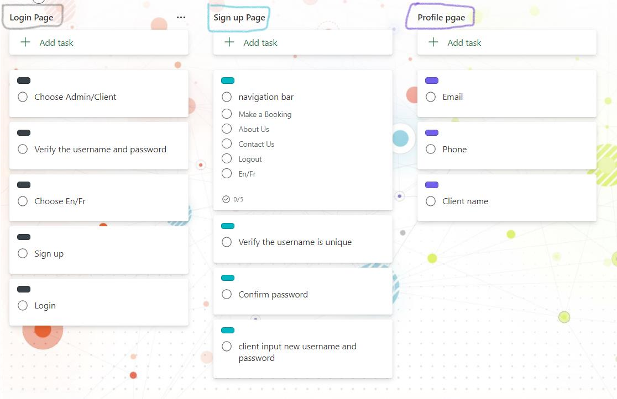

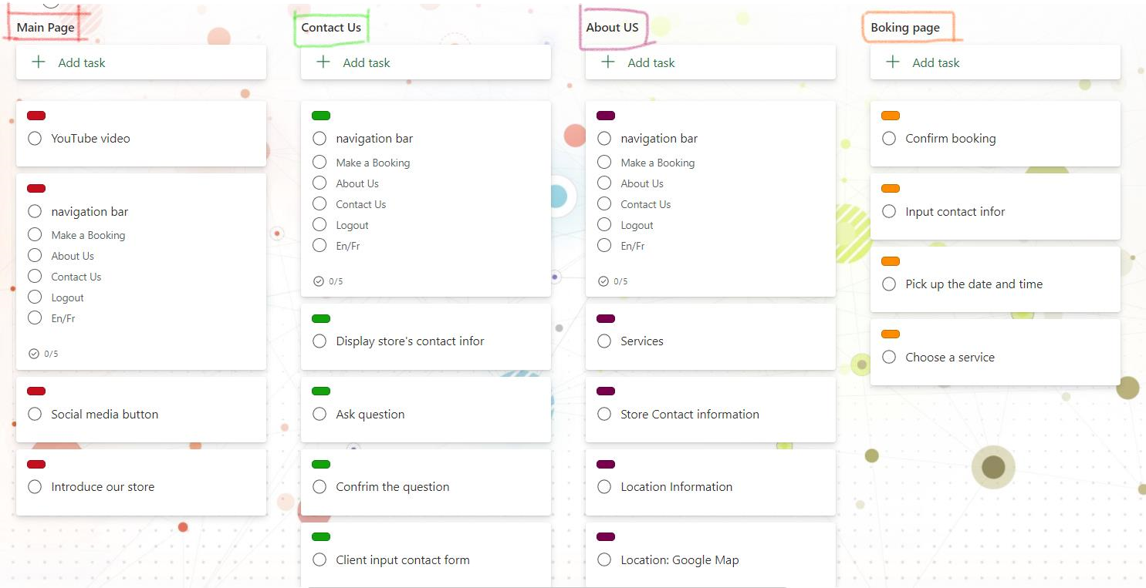

**Admin:**

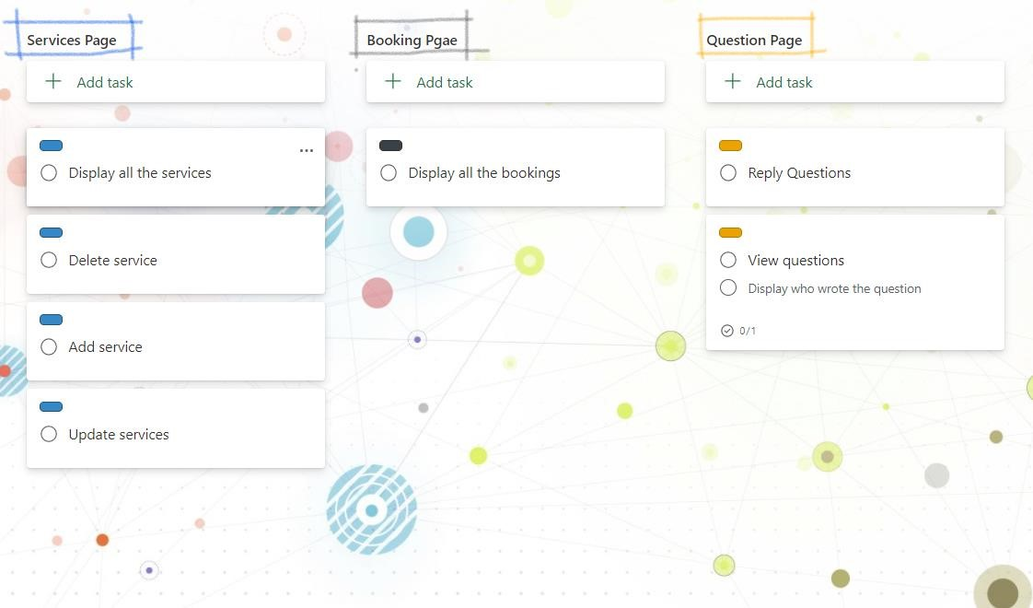

# CONFIRMATION OF EACH TEAM MEMBER

**Signature:** 

**Printed Name: Theodore Tsimiklis**  **Date: 2022-03-30**

**Signature:** 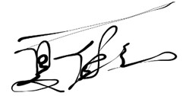

**Printed Name: Jiahui Xia** **Date: 2022-03-30**

**Signature:** 

**Printed Name: George Athanasatos** **Date: 2022-03-30**

**Signature:** 

**Printed Name: Andrei Marinescu** **Date: 2022-03-30**

# References

*30 examples of Business Problems*. Simplicable. (n.d.). Retrieved February 17, 2022. <https://simplicable.com/new/business-problems>

*Peintre Prestige. Simplified* (n.d.). Retrieved March 16, 2022.

<https://peintresprestigemontreal.com/contact>[-us/](https://peintresprestigemontreal.com/contact-us/)

*Benjamin Moore. Simplified* (n.d.). Retrieved March 16 2022.

<https://www.benjaminmoore.com/en>[-ca/login?ref=%2Fen-ca%2F](https://www.benjaminmoore.com/en-ca/login?ref=%2Fen-ca%2F)